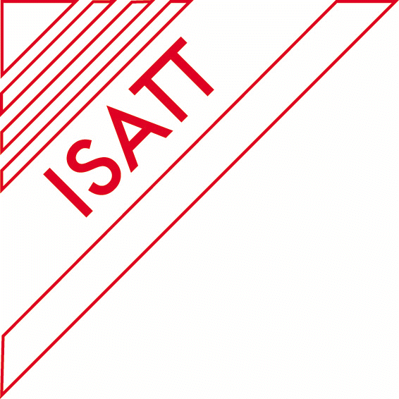
INFORMATION LETTER

MINISTRY OF EDUCATION AND SCIENCE OF RUSSIAN FEDERATION
RUSSIAN ACADEMY OF EDUCATION
INTERNATIONAL STUDY ASSOCIATION ON TEACHERS AND TEACHING
KAZAN (VOLGA REGION) FEDERAL UNIVERSITY
INSTITUTE OF PSYCHOLOGY AND EDUCATION

hold

IV INTERNATIONAL FORUM ON TEACHER EDUCATION

ISATT REGIONAL CONFERENCE

“PROFESSIONALISM OF THE TEACHER AS A CONDITION OF THE QUALITY OF EDUCATION”

The Forum will be held on May 22-24, 2018.

The objectives of the conference:
- Study of historical background, trends and characteristics of teacher education;
- Analysis and summarizing of theoretical and practical, traditional and innovative approaches to modernization of teacher education;
- Scientific and methodological support of the quality of modern teacher education for changing world;
- Familiarization with the practice of teacher education abroad;
- Exchange of teaching techniques, materials and experience.

The main subjects of the Forum:
- Modeling of individual and professional teacher of new type;
- Problems of modernization and development of the content of vocational teacher education to meet the requirements of the changing world;
- Implementation of the competence-based approach in a system of continuous teacher education;
- Problems of training future teachers to educational activities in a multi-cultural environment;
- Educational technologies for personal and professional development of multi-cultural teachers;
- Integration of the vocational pedagogical and classical university education in the preparation of a new type of teacher;
- Problems of improving the system of continuing teacher education;
- Implementation of the educational potential of the educational process and extracurricular activities in the preparation of a new type of teacher;
- International experience as a source of innovation in improving the national system of teacher education.

Range of topics can be expanded in the context of the theme of the conference.

Sub-conferences held during the Forum
- International Conference “The integration of theory and practice in subject teacher education”,
- International Conference “Preparing teachers to be role models and moral leaders” and
- International Conference "Children's Behavioural Problems: pedagogical methods of prevention and overcoming ".
The Forum hosts participation of leading Russian and foreign experts on teacher education.
The invitation to participate in the Conference extends to employees of regional and municipal education authorities, teaching staff and representatives of the administration of educational institutions of general education, secondary, higher and tertiary vocational teacher education, as well as members of scientific and other institutions related to the theoretical and practical study of the problem.

Applications for participation in the Conference and abstracts must be submitted prior to January 31, 2018 on the site of the Forum: http://ifte.kpfu.ru/

Abstract Submission

The abstract (500 words) includes Problem Statement, Purpose of Study, Methods, Findings and Results, Conclusions and Recommendations, and Key words. These elements may need some adaptation in the case of discussion papers: Background, Purpose of Study, Sources of Evidence, Main Argument, Conclusions, and Key words. Please note that these elements are optional in abstracts.
Please submit your abstract on-line after registration on the site of the Forum: http://ifte.kpfu.ru/

Proceedings of the II International Forum on Teacher Education (IFTE-2016) were published in the European Proceedings of Social and Behavioral Sciences, and indexed in the database Web of Science (http://www.futureacademy.org.uk/publication/EpSBS/IFTE2016VolumeXII). Proceedings of the III International Forum on Teacher Education (IFTE-2017) were published in the European Proceedings of Social and Behavioral Sciences

Registration Fee at the Forum is 100$, including transfer from airport or railway station, lunches, guided tours and social program, bag with program and learning materials, interpreters

Visa information.
If you need visa we’ll send you the visa invitation and you may address the Russian Consulate in your city. Preparing the visa invitation takes about 2-3 weeks. Usually getting visa in the Consulate takes about 10 days. Please, fill in the form and send it with the copy of your passport to the e-mail: ipe-dfa@ya.ru

Surname | Given Name | Passport No. | Expiry date
Date of issue |  | Birth date dd/mm/yy
Place of Birth |  | Sex
Mailing Address
e-mail |  | Mobile phone
Fax |  | Phone (at home)
Organization, telephone, fax, e-mail |  | Occupation
Arrival date |  | Departure date
Period of your stay in Kazan |  | Hotel address in Kazan
What other cities are you going to visit in Russia |  | In what city are you going to obtain a visa

The Post-Forum Event will be organized on the 25-27th of May aboard a four-deck ship named after Fedor Panferov. We’ll go along the Volga-river from Kazan to Samara. The cost of the boat-trip is 250 Euro. It includes three meals a day, guided tours and accommodation. The mode of payment will be announced later. Please send the confirmation of your participation in the boat-trip before the 31st of January to the e-mail: ipe-dfa@ya.ru

Should you have any question regarding organization and participation in the International Forum, please, contact us: 420021, Kazan, M. Mezhlayuk Str., 1. e-mail: ipe-dfa@ya.ru

Executive Secretary of the Organizing Committee – Dr. Roza Valeeva, professor, Deputy Director for International Cooperation, Head of the Pedagogy Department in the Institute of Psychology and Education, Kazan (Volga Region) Federal University, contact phone +7 9061 137 120, e-mail: valeykin@yandex.ru.

Contact phone and fax number in Kazan, Russia: +7 (843) 2929123

Note. Kazan is a big ancient city, 800 km from Moscow to the south-east with the population of about 1.5 million people. It is the capital of the Republic of Tatarstan and lies on the left bank of the Volga. It is a large cultural center: 5 theaters, Concert Hall, 15 Universities. One can get to Kazan by night train or by air from Moscow.

