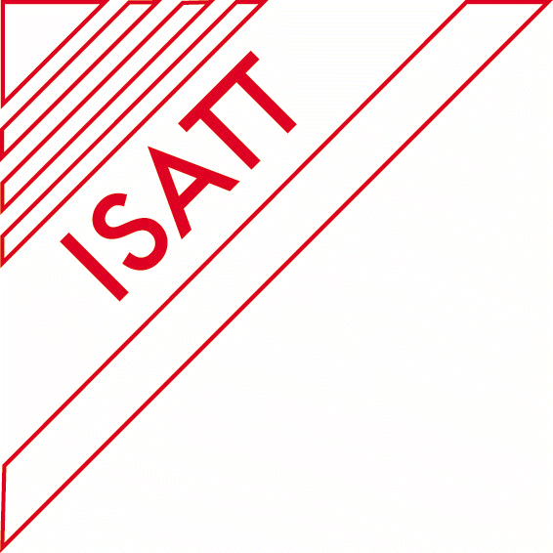
ANNOUNCEMENT OF ISATT CROSS-CULTURAL RESEARCH COLLABORATION GRANT PROGRAMME
CALL FOR PROPOSALS
Maximum of 3 Research Grants of £2000 Each
Available to ISATT Members

Description and Eligibility
ISATT seeks ISATT member proposals for a maximum of THREE cross-cultural research collaborative grants of £2000 each, that will be awarded to a team of researchers from at least four diverse countries working collaboratively to conduct a shared inquiry over a twelve-month period.
Grant Proposals (maximum five pages, single spaced, including references) must be submitted online as PDF files to Daniela Hotolean at d.hotolean@reading.ac.uk no later than 15 August 2025 along with the attached Cover Sheet, the attached Budget Sheet, and the curriculum vitas of all collaborative research partners.
The Cross-cultural Research Collaboration is described as research which is in the declared interest of all participants and in which each is an equal contributor. Each research collaborator must be an active participant in the design, conduct, evaluation, and dissemination of the research. The collaborative research study must be completed by 30 November 2026 at which time the grant recipients will submit all the original receipts for expenses* in order to be reimbursed by ISATT (up to a maximum of £2000).
The £2000 award can be used for supplies, photocopying, transcription, videoconferencing expenditures, small equipment costs (i.e., recording devices), travel, registration fee and/or accommodation to the ISATT conference where the paper based on this research is presented etc. The £2000 award cannot be used for tuition costs, honorariums, consulting fees, and the purchase of hardware. Awardees are responsible for submitting all original receipts of expenditures for reimbursement. At the end of the grant, Awardees must submit their original receipts, together with a completed paper on their collaborative research no later than 30 November 2026, together with the completed final research paper (minimum of 25 pages - A4 pages double spaced, APA Style, including abstract, author biographies, and references). Awardees will be provided with a separate form for expense reporting purposes. All submitted original receipts must be acceptable to the ISATT Treasurer and the organization’s auditor.

Review
Proposals will be peer reviewed by members of ISATT’s Scientific Research Committee. Proposals must include all the elements outlined in the proposal guidelines. Announcements of Cross-cultural Research Collaboration Grants will be made by 15th October 2025.

Purpose
The natural potential for knowledge production using plurality of interacting international educators’ lived experiences which ISATT held with its profile of international membership, took a visible shape during the COVID pandemic. The ISATT National Reps’ coordinator, Tara Ratnam, initiated a collaborative project which provided its National Reps from around the globe a virtual community space where they could share the destabilizing experience they were going through in their intertwined personal and professional lives and gain a perspective on it collectively. 24 members from 22 countries who took part in this three-year collaborative project look upon this experience as something unique and rewarding. The findings from the four studies undertaken during the COVID-19 pandemic were presented at the ISATT conference in Bordeaux and Bari and also compiled into a section in the 40th Anniversary ISATT Yearbook. This provided the motive to expand the ISATT collaborative project to encompass all its members. We are currently working with 70 ISATT members from different member countries on addressing critical challenges in teaching and teacher education across five research topics. The ISATT cross-cultural collaborative project has provided a reason for several new members to join the ISATT fold. The Cross-cultural Research Collaboration Grant Programme has been established to encourage and support more educators and researchers from diverse member countries to undertake international collaborative research leveraging the cross-cultural learning potential afforded by ISATT and contribute new insights and knowledge to the persisting education and teacher education conundrums globally.
The Cross-cultural Collaborative Research Grant Programme Call is an open one. This means that collaborative research teams (formed with a minimum participation from four different member countries) can submit proposals around their self-selected areas of interest, providing those interests fall under the banner of ISATT’s declared mission. It is expected that the outcome of the collaborative research undertaken is presented at the next biennial ISATT conference to be held in 2027.

Proposal Guidelines
Grant proposals must include the following documents. Save all documents in PDF format and send electronically to Daniela Hotolean at d.hotolean@reading.ac.uk. The Deadline for applications is 15 August 2025.
- Project Proposal: Maximum of 5-Pages, Single-Spaced Project Descriptions in 12-point type must include:
  - Justification of Chosen Research Topic (i.e., historical, personal, practical, organisational)
  - Description of what interests the partners in the topic/the collaboration
  - Description of the research method/tools/analytical processes
  - Description of participant selection
  - Special Features
  - Anticipated outcomes
  - Contributions to ISATT

- Cover Page: Completed and signed by all the project coordinators from four or more collaborating countries (see form below).
- Curriculum Vita: Recent Curriculum Vitas of all the coordinators.
- Research Budget Overview and Justification: List the proposed expenditures for grant related activities/materials. Briefly provide a justification for each proposed expense. The £2000 award can be used for supplies, photocopying, transcription, videoconferencing expenditures, small equipment costs (e.g., recording devices), travel, registration fee and/or accommodation to ISATT conference where the paper based on this research is presented, etc. The £2000 award cannot be used for tuition costs, honorariums, consulting fees, and the purchase of hardware.

Awardees must submit original receipts for reimbursement*, together with the completed collaborative research paper, no later than 30 November 2026. The final paper (minimum of 25 pages, including abstract, author biographies, and references) may include photographs, historical artifacts (i.e., excerpts from conference programmes/conference proceedings), and live links to video/audio-taped conversations that emerged as part of the research process. Awardees are responsible for submitting original receipts of expenditures for reimbursement. Submitted original receipts must be acceptable to the ISATT Treasurer and the organization’s auditor. Awardees will be provided a separate form for expense reporting purposes.

ISATT Acknowledgement for Publication
All published work arising from the collaborative research supported by the awarding of a grant from ISATT must include a statement acknowledging ISATT’s support (e.g., this research project was supported by a Collaborative Research Grant from the International Study Association on Teachers and Teaching [ISATT]). This includes the Final Research Paper for this grant, presentations, and/or any other publications that result from the Collaborative Research Grant.

ISATT CROSS-CULTURAL RESEARCH COLLABORATION GRANT PROGRAMME Cover Page
Coordinator 1: Click or tap here to enter text.
University of Affiliation: Click or tap here to enter text.
ISATT Region: Click or tap here to enter text. Member: ☐
Address: Click or tap here to enter text.
Email: Click or tap here to enter text.
CV attached : ☐

Coordinator 2: Click or tap here to enter text.
University of Affiliation: Click or tap here to enter text.
ISATT Region: Click or tap here to enter text. Member: ☐
Address: Click or tap here to enter text.
Email: Click or tap here to enter text.
CV attached: ☐

Coordinator 3: Click or tap here to enter text.
University of Affiliation: Click or tap here to enter text.
ISATT Region: Click or tap here to enter text. Member: ☐
Address: Click or tap here to enter text.
Email: Click or tap here to enter text.
CV attached: ☐

Coordinator 4: Click or tap here to enter text.
University of Affiliation: Click or tap here to enter text.
ISATT Region: Click or tap here to enter text. Member: ☐
Address: Click or tap here to enter text.
Email: Click or tap here to enter text.
CV attached: ☐
Title of Study:
200 Word Abstract (for award announcement purposes)

Click or tap here to enter text.

Coordinator 1 Signature and date ____________________________________
Coordinator 2 Signature and date____________________________________
Coordinator 3 Signature and date____________________________________
Coordinator 4 Signature and date____________________________________

ISATT CROSS-CULTURAL RESEARCH COLLABORATION GRANT PROGRAMME Research Budget Overview and Justification Form
Using the form below, list the prepossessed expenditures for grant related activities/materials. Briefly provide a justification for each proposed expense. The £2000 award can be used for supplies, photocopying, transcription, videoconferencing expenditures, small equipment costs (i.e., recording devices), for travel, registration fee and/or accommodation to ISATT conference where the paper based on this research is presented. The £2000 award cannot be used for tuition costs, honorariums, consulting fees, and the purchase of hardware.
At the end of the grant, Awardees must submit original receipts*, together with the completed 25-page paper on their collaborative research no later than 30 November, 2026. Awardees are responsible for submitting original receipts of expenditures for reimbursement. Submitted original receipts must be acceptable to the ISATT Treasurer and the organization’s auditor. Awardees will be provided a separate form for expense reporting purposes.

Coordinator 1 Signature and date ___________________________________
Coordinator 2 Signature and date ___________________________________
Coordinator 3 Signature and date____________________________________
Coordinator 4 Signature and date____________________________________
 | Proposed Expenditure | Justification of Expenditure
1 | Click or tap here to enter text. | Click or tap here to enter text.
2 | Click or tap here to enter text. | Click or tap here to enter text.
3 | Click or tap here to enter text. | Click or tap here to enter text.
4 | Click or tap here to enter text. | Click or tap here to enter text.
5 | Click or tap here to enter text. | Click or tap here to enter text.
6 | Click or tap here to enter text. | Click or tap here to enter text.
7 | Click or tap here to enter text. | Click or tap here to enter text.
8 | Click or tap here to enter text. | Click or tap here to enter text.

It’s not expected that receipts related to expenses for travel, accommodation or registration fees to next ISATT biennial conference will be submitted at this point. These will need to be submitted at the conference or shortly after.

